## AKSHAYA PATRA FOUNDATION

## 

## MINI PROJECT REPORT

**on**

**AKSHAYA PATRA FOUNDATION**

**Submitted in partial fulfilment for the completion of**

**III Semester of B.E.**

**INFORMATION TECHNOLOGY**

**By**

**ADITI INDOORI (160118737001)**

**AMARRAJU DEVI ABHIGNA (160118737002)**

**SLS HARSHITHA (160118737008)**

**SATHVIKA PATWARI (160118737016)**

**Under the guidance of**

**Dr.CH.SUVARNA RAGINI**



**DEPARTMENT OF INFORMATION TECHNOLOGY**

**CHAITANYA BHARATHI INSTITUTE OF TECHNOLOGY (A)**

**(Affiliated to Osmania University; Accredited by NBA(AICTE) and NAAC(UGC), ISO Certified 9001:2015)**

**GANDIPET, HYDERABAD – 500 075**

**Website:** [**www.cbit.ac.in**](http://www.cbit.ac.in)

**2019-2020**

**CHAITANYA BHARATHI INSTITUTE OF TECHNOLOGY (A)**

DEPARTMENT OF INFORMATION TECHNOLOGY

**(Affiliated to Osmania University)**

**GANDIPET, HYDERABAD – 500 075**



**CERTIFICATE**

This isto certify that **ADITI INDOORI (160118737001), AMARRAJU DEVI ABHIGNA (160118737002), SLS HARSHITHA (160118737008), SATHVIKA PATWARI (160118737016)** of B.E 2/4 INFORMATION TECHNOLOGY have completed the mini project conducted by soft skills and employability enhancement lab at **CHAITANYA BHARATHI INSTITUTE OF TECHNOLOGY** during the academic year 2019-2020.

**Faculty In-charge**  **External Examiner**

**CONTENTS**

**Page No.**

**ACKNOWLEDGEMENT** i

**DECLARATION** ii

**ABSTRACT** iii

1. **INTRODUCTION** 1

* 1. Motivation 1
  2. Basic Definitions 1
  3. Problem Statement 2

1. **EXISTING SYSTEM** 3

1. **PROPOSED SYSTEM** 4
   1. Methodology 4
   2. Architecture of Proposed System 5
2. **SOF****TWARE & HARDWARE REQUIREMENTS** 7
3. **IMPLEMENTATION OF PROJECT** 8
   1. Results 8
4. **CONCLUSION & FUTURE SCOPE** 15
5. **BIBLIOGRAPHY** 16

**ACKNOWLEDGEMENT**

It gives us immense pleasure in presenting this project report on “AKSHAYA PATRA FOUNDATION”. We are overwhelmed and extremely grateful to have got this wonderful opportunity to work on this phenomenal project through which we have garnered plentiful knowledge and experience.

We would like to express our deepest gratitude to all those who have helped us with our mini project right from its commencement.The final outcome of this assignment required a lot of guidance and assistance from many people and we are extremely fortunate to have got all this along the completion of our work. Our respects and regards toDr.Ch.Suvarna Ragini ma’am**,** for giving us the opportunity to do this project. Her invaluable suggestions, encouragement and supportive guidance helped us in the successful completion of this project. We are also glad to have got the opportunity to work with each other. This project couldn’t have been completed without the effort and cooperation among all the members in our group. Last but not the least, we would like to thank our friends, and all our family members who with their valuable suggestions, support and assistance, directly or indirectly helped us in the completion of this project.

**PROJECT DESCRIPTION**

Non-governmental organizations - commonly referred to as NGOs, are usually non-profit independent of governments, many are active in humanitarian etc. areas; however, NGOs can also be as lobby groups for corporations. NGOs are also sometimes expanded to nongovernmental or nongovernment organizations. They are thus a subgroup of all organizations founded by citizens, which include clubs and other associations that provide services, benefits, and premises only to members. NGOs are usually funded by donations, but some avoid formal funding altogether and are run primarily by volunteers. NGOs are highly diverse groups of organizations engaged in a wide range of activities, and take different forms in different parts of the world. Some may have charitable status, while others may be registered for tax exemption based on recognition of social purposes.

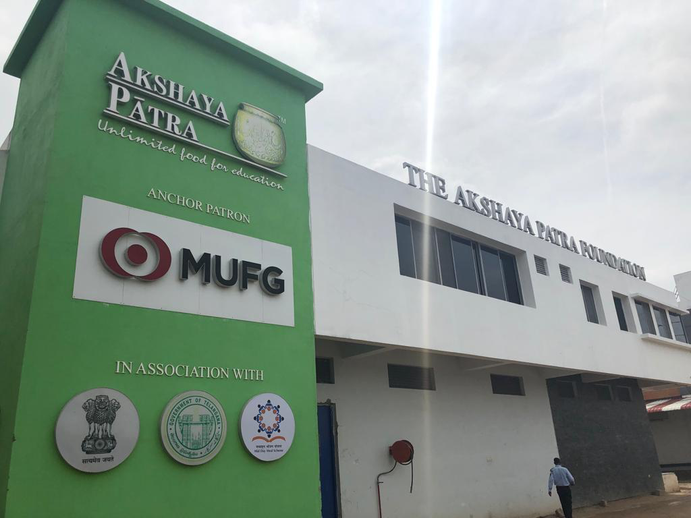

**BRANCH: KOKAPET**

**PROJECT PROFILE**

**LOGO:**

**FOUNDER:** Madhu Pandit Dasa

**BRANCHES:** There are 51 kitchens across 12 States & 2 Union Territories of India

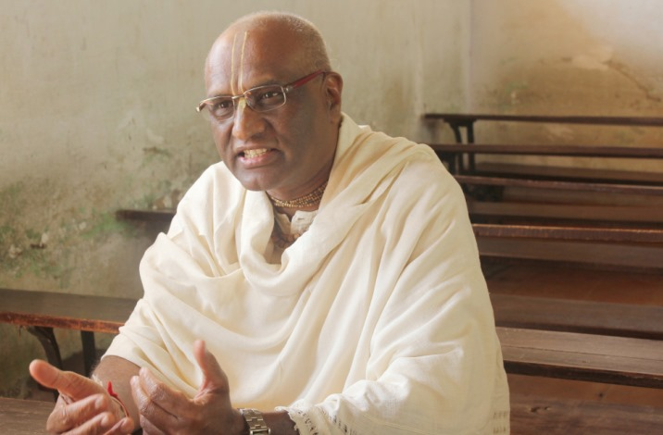

**ABSTRACT**

This project report is about the prestigious organisation – Akshaya Patra. In this report, we would like to shed light upon the history, ideology, work and impact of The Akshaya Patra Foundation.

The Akshaya Patra Foundation is a non-profit organisation in India that runs school lunch programme across India. The organisation was established in 2000 by Sri. Madhu Pandit Dasa. It aims to counter classroom hunger and aid in education of children. It feeds 17,62,133 children every day across India. The food distributed by Akshaya Patra is perceived to be "hygienic, nutritious and delicious". The Akshaya Patra Foundation operates in 51 kitchens across 12 states & 2 Union territory of India.

**INTRODUCTION**

The Akshaya Patra Foundation is a not-for-profit organisation headquartered in Bengaluru, India. The organisation strives to eliminate classroom hunger by implementing the Mid-Day Meal Scheme in the government schools and government-aided schools. Alongside, Akshaya Patra also aims at countering malnutrition and supporting the right to education of socio-economically disadvantaged children.

Since 2000, Akshaya Patra has been concerting all its efforts towards providing fresh and nutritious meals to children on every single school day. The organization is continuously leveraging technology to multiply their reach. The state-of-the-art [kitchens](https://www.akshayapatra.org/our-kitchens) have become a subject of study and have attracted curious visitors from around the world. Their partnership with the Government of India and various State Governments, along with the persistent support from corporates, individual donors, and well-wishers have helped them to grow from serving just 1,500 children in 5 schools in 2000 to serving 1.8 million children. Today, Akshaya Patra is the world’s largest (not-for-profit run) Mid-Day Meal programme serving wholesome food every school day to over 1.8 million children from 16,856 schools across 12 states & 2 Union territories of India.

**HISTORY**

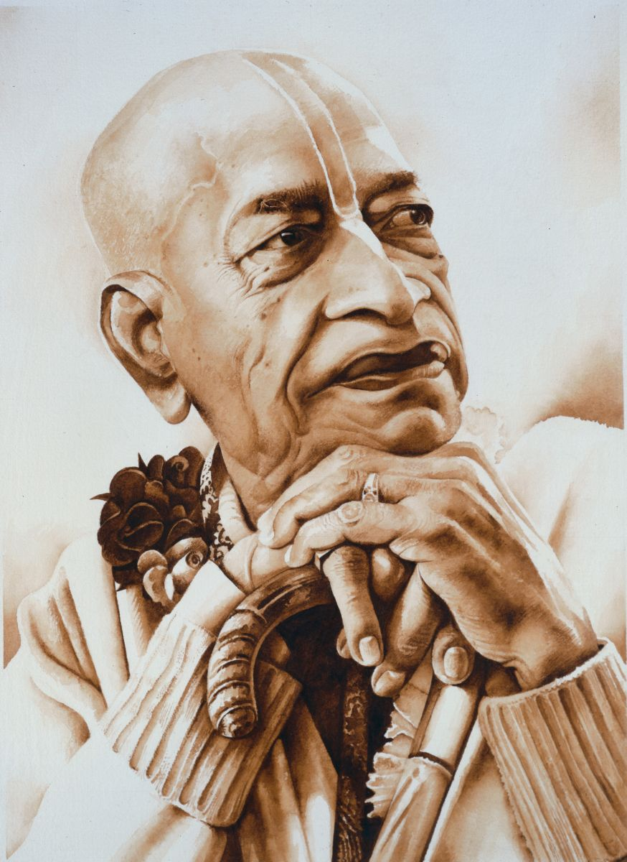

The history of how the existence of The Akshaya Patra Foundation came about dates back to the late 70’s.

Looking out of a window, one day in Mayapur, a village near Calcutta, his divine grace A. C. Bhaktivedanta Swami Prabhupada saw a group of children fighting with stray dogs over scraps of food. From this simple, yet heart-breaking incident was born a determination that no child within a radius of ten miles from his center should go hungry.

His inspiring resolve sowed the seeds of The Akshaya Patra Foundation. With the vision: "*No child in India shall be deprived of education because of hunger,"*Akshaya Patra started the Mid-Day Meal Programme in June 2000 by serving mid-day meals to 1,500 children across five government schools in Bengaluru, Karnataka. A humble beginning, yet, the initial days of implementing the programme was not a smooth sail. Soon came the helping hands of Mohandas Pai, who took the initiative of donating the first vehicle to transport food to the schools; and Abhay Jain, who promised to bring in more donors to contribute for the further expansion of the programme.

In partnership with the Government of India and various State Governments, as well as philanthropic donors; the organization is running the world’s largest Mid-Day Meal Programme. Built on a Public-Private Partnership model, Akshaya Patra combines good management, innovative technology, and smart engineering to deliver nutritious and hygienic school lunch on every school day.

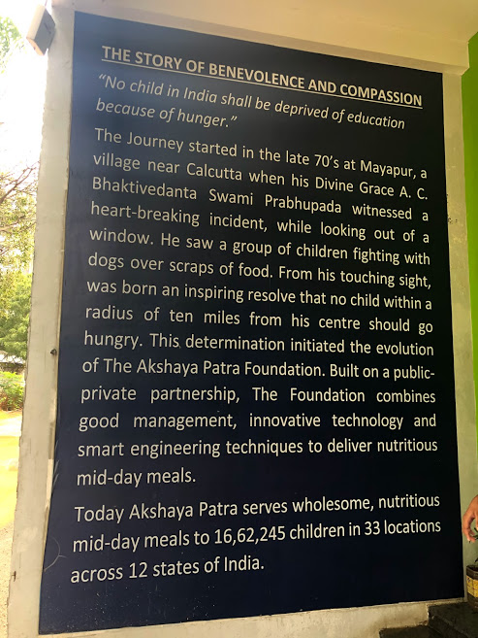

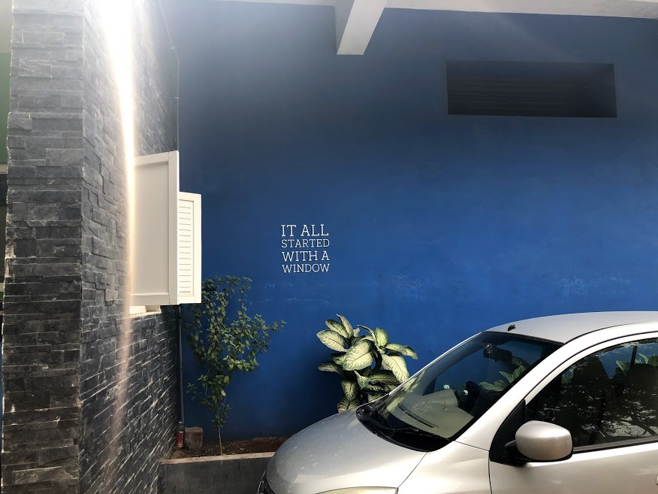

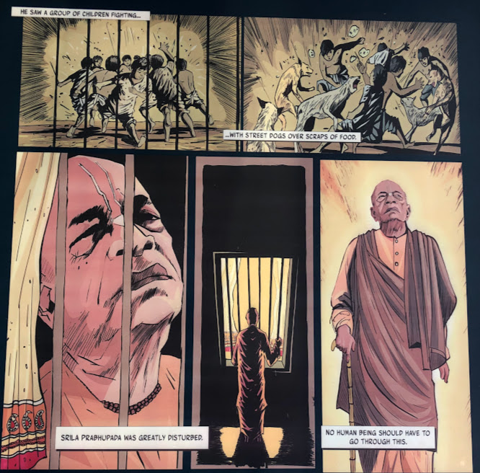

**VISION, MISSION AND WORK**

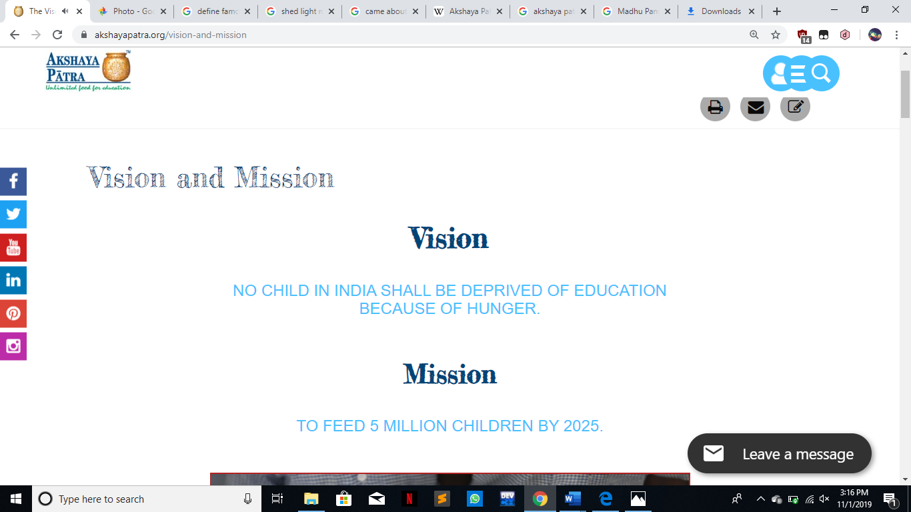

Through the Mid-Day Meal Programme, the attempt is to feed the millions of children in India who lack the means, but have the zeal to learn and achieve. By feeding them one wholesome meal a day, they are given the nourishment and motivation they need, to pursue an education for a better future. It is their endeavor to reach out to every child at the grass root level of the society.

The Akshaya Patra Foundation is a non-profit organization that operates on a public-private partnership (PPP) model. Since Akshaya Patra acts as an implementing partner of the Mid-Day Meal Scheme, there is a firm support from the Government of India, the State Governments and associated organizations. This has enabled Akshaya Patra’s school lunch programme to grow from feeding 1,500 children in the year 2000 to over 1.8 million children in 2019. On 11 February 2019, the organization commemorated the serving of 3 billion meals (cumulative).

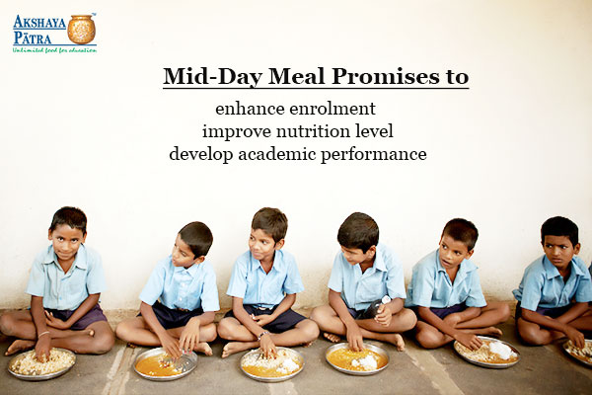

While the Mid-Day Meal Programme, with an aim to end classroom hunger, has been reaching out to millions of school children every day with freshly-cooked nutritious meals, statistics show that children in India are in need of immediate attention.

**Status of children in India**

- According to UNESCO Out-of-School children report (published in 2015), 17.7 million children in India are estimated to be out of school

- School dropout in Uttar Pradesh leads with 1.6 million out of school children, followed by Bihar and Rajasthan

Akshaya Patra also depends on corporate funds, philanthropic donors, volunteers and well-wishers for managing this large operation. The details of the operation include technological innovations, quality standards, delivery vehicles and interacting with various stakeholders.

The organization is highly transparent and makes available not only the financial information but also intellectual property to the public. Akshaya Patra believes that there is a dire need for the school lunch programme to be replicated so that it realizes the vision that “No child in India shall be deprived of education because of hunger.”

Akshaya Patra reaches out to 18,02,517 children in 51 kitchens across 12 States & 2 Union Territories of India, providing them with freshly cooked meal on all school days. Currently, they implement the mid-day meal programme in 16,856 schools of the country, with plans to increase that number to hundreds more.

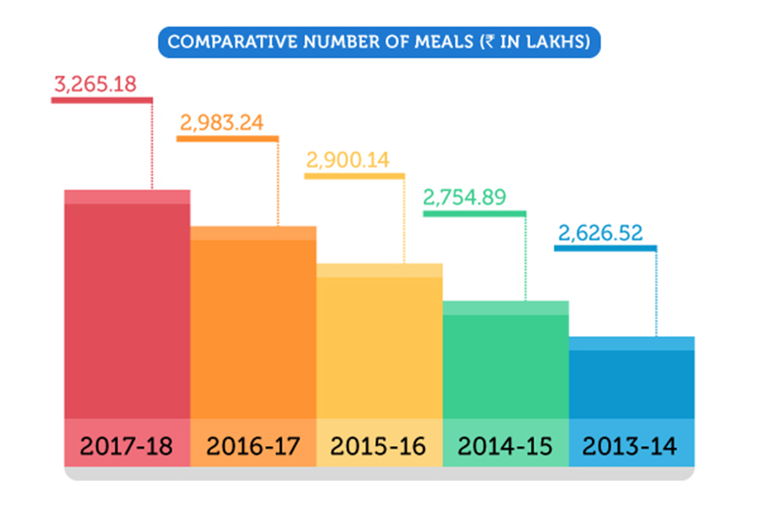

**FUNDS**

**Small gestures can have a big impact. Create an impact where it matters.**

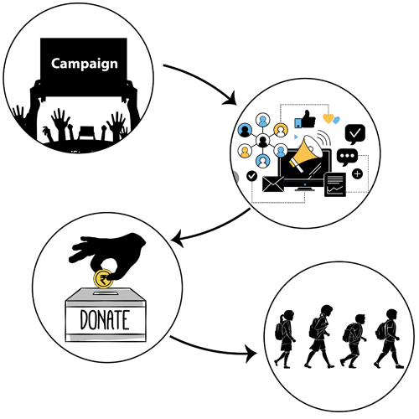

**Start a Campaign:** Sign in or register and create an online fundraising campaign by filling in the required details.

**Create Awareness:** Once the campaign has been created, share the link on Facebook, Twitter and other social media channels and let your friends know.

**Raise Funds:** Tell your friends and family that they can support Akshaya Patra by contributing to your purposeful campaign.

**Make an Impact:** Know that all the funds raised through your campaign will be utilised to provide nutritious meals to school children every day!

**What is a fundraising campaign?**

• A fundraising campaign is an initiative to gather voluntary contributions by involving your friends and family. The money raised in these campaigns will be used to feed children benefitting from Akshaya Patra’s school lunch programme.

• You can take up an online fundraising campaign on the website. Once you pick a fundraising idea and complete the required formalities, your campaign will be live. You can then share it on your social media channels to create awareness regarding the same, and get people to donate to the campaign.

• You can celebrate special occasions with us – birthdays, anniversaries and the like – by creating a fundraising campaign.

• You can also fix upon a charity fundraising amount you want to raise.

**Top of Form**

**Bottom of Form**

**Ganny Chicago Marathon Campaign**

**Created By : Mr Ganesh Sundaresan**

**AddThis Sharing Buttons**

**Share to FacebookShare to TwitterShare to LinkedInShare to WhatsAppShare to GmailShare to WordPress**

**`**



**Campaign Goal Rs. 33,354.00**

**100%**

**Raised So Far Rs. 33,355.00**

**Ek Thali**

**Created By : Mr PARAG BADIANI**

**AddThis Sharing Buttons**

**Share to FacebookShare to TwitterShare to LinkedInShare to WhatsAppShare to GmailShare to WordPress**

**`**

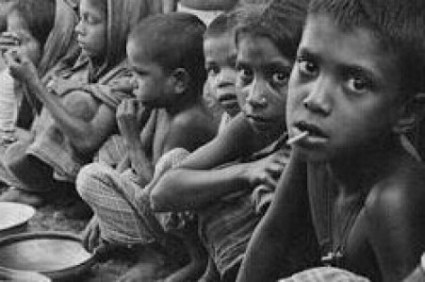

**Campaign Goal Rs. 10,000.00**

**Raised 65%**

**So Far Rs. 6,450.00**

**FINANCIALS**

**How is your money spent?**

Your money ultimately is for the children. Every donation is diligently spent for the food that is served directly or indirectly.  On an average, 92% of the total funds is used towards meeting the programme cost and 8% towards the programme management cost. The organisation upholds maximum transparency in funds utilisation.

***Cost Per Meal Calculation:***

| **Cost Elements** | **Cost per Meal** |
| --- | --- |
| **PROGRAM COSTS** | **11.42** |
| Cost of materials & utilities, distribution costs and factory overheads including manpower, Repairs, depreciation and other factory running expenses |  |
| **Administrative Overheads** | **0.42** |
| Cost of activities relating to General Management and Administration |  |
| **Outreach Cost** | **0.62** |
| Cost of publicity, communication, Donor Reporting, Advocacy and travel related |  |
| **Gross Cost per Meal in Rs.** | **12.46** |
| Less: Subsidy from Government per meal | **6.28** |
| Less: Interest and other income | **1.38** |
| **Cost to be absorbed by TAPF per meal through donations** | **4.8** |
| National Average of school working days in an academic year | **232** |
| **Cost to run the MDM program for 1 child per year in Rs.** | **1,113.96** |
| **Rounded off to** | **1,100.00** |

**Cost Per Meal Calculation:**

| **Cost Elements** | **Cost per Meal** |
| --- | --- |
| **PROGRAM COSTS** | **11.42** |
| Cost of materials & utilities, distribution costs and factory overheads including manpower, Repairs, depreciation and other factory running expenses |  |
| **Administrative Overheads** | **0.42** |
| Cost of activities relating to General Management and Administration |  |
| **Outreach Cost** | **0.62** |
| Cost of publicity, communication, Donor Reporting, Advocacy and travel related |  |
| **Gross Cost per Meal in Rs.** | **12.46** |
| Less: Subsidy from Government per meal | **6.28** |
| Less: Interest and other income | **1.38** |
| **Cost to be absorbed by TAPF per meal through donations** | **4.8** |
| National Average of school working days in an academic year | **232** |
| **Cost to run the MDM program for 1 child per year in Rs.** | **1,113.96** |
| **Rounded off to** | **1,100.00** |

*Note: Revised as on 1st July 2018*

**Analysis of the total revenue expenditure for the year 2017-18:**

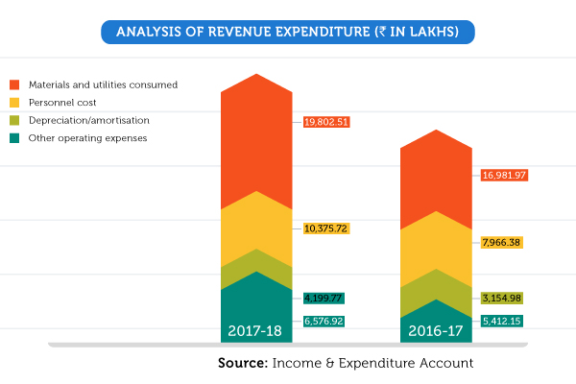

# Transparency

Transparency, especially for an NGO, is the key to trust and reliability. Akshaya Patra hence upholds absolute transparency in all its activities.

For this purpose, we comply with the International Financial Reporting Standards (IFRS). The IFRS reporting which was adopted in 2008-09 has contributed substantially to building confidence amongst the stakeholders of the organisation.

We also comply with the Indian Accounting Standards issued by the Institute of Chartered Accountants of India (ICAI) and are up to date on accounting standards. At the end of each financial year, an Annual Report with financial audits and statements is published and made available to the stakeholders.

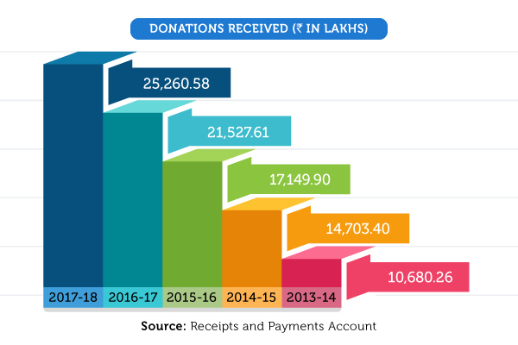

[Notifications Powered By Feedify](https://feedify.net/?utm_source=referral&utm_medium=PoweredBy&utm_campaign=https%3A%2F%2Fwww.akshayapatra.org%2Fhow-your-money-spent)